JOB APPLICATION TRACKER
@CREATIVITY THINK (9483175986/7019689991)

ABSTRACT:
Job Application Tracker is a web-based platform designed to assist career seekers, recruitment agencies, and education centers in managing job applications efficiently. The system enables users to upload applications, monitor status, schedule interviews, manage related documents, and view analytics dashboards. Administrators can manage job listings, applicants, interview schedules, and generate detailed reports. Developed with Django and Django Rest Framework for the backend and React with redux and pdfkit for the frontend, the platform provides secure, scalable, and organized tracking of job applications, ensuring seamless management and decision-making..

INTRODUCTION OF THE PROJECT:
Managing job applications manually or via spreadsheets can lead to missed deadlines, confusion in interview scheduling, and disorganized document management. Job Application Tracker solves these challenges by offering a centralized solution for uploading applications, tracking status, scheduling interviews, and monitoring progress through interactive dashboards. Users and administrators benefit from real-time updates, automated workflows, and analytical insights, improving efficiency, transparency, and overall career management or recruitment operations..

PROJECT OBJECTIVES:

• Provide a secure platform for uploading and managing job applications
• Enable users to track the status of submitted applications
• Manage interview schedules and reminders
• Allow document uploads and management for applications
• Provide dashboards with analytics for user and admin insights
• Allow administrators to add and manage job listings
• Facilitate monitoring of applicants and interview schedules
• Generate reports to support recruitment and career decision-making

PROBLEM OF THE STATEMENT:
Traditional job application tracking methods, such as emails, spreadsheets, or paper records, are inefficient, prone to errors, and lack structured reporting. Applicants may lose track of their submissions, and administrators struggle with organizing interviews, documents, and candidate data. Job Application Tracker provides a centralized, organized, and automated system, ensuring accurate status tracking, document management, interview scheduling, and analytics for all stakeholders..

MOTIVATION OF THE PROJECT:
• To provide a digital and efficient solution for tracking job applications
• To ensure transparency in application status and recruitment processes
• To reduce manual errors and confusion in interview scheduling
• To enable document organization and storage in one platform
• To offer analytics-driven insights to administrators
• To simplify career management for job seekers
• To improve operational efficiency for recruitment agencies and centers

BLOCK DAIGRAM OF PROJECT:

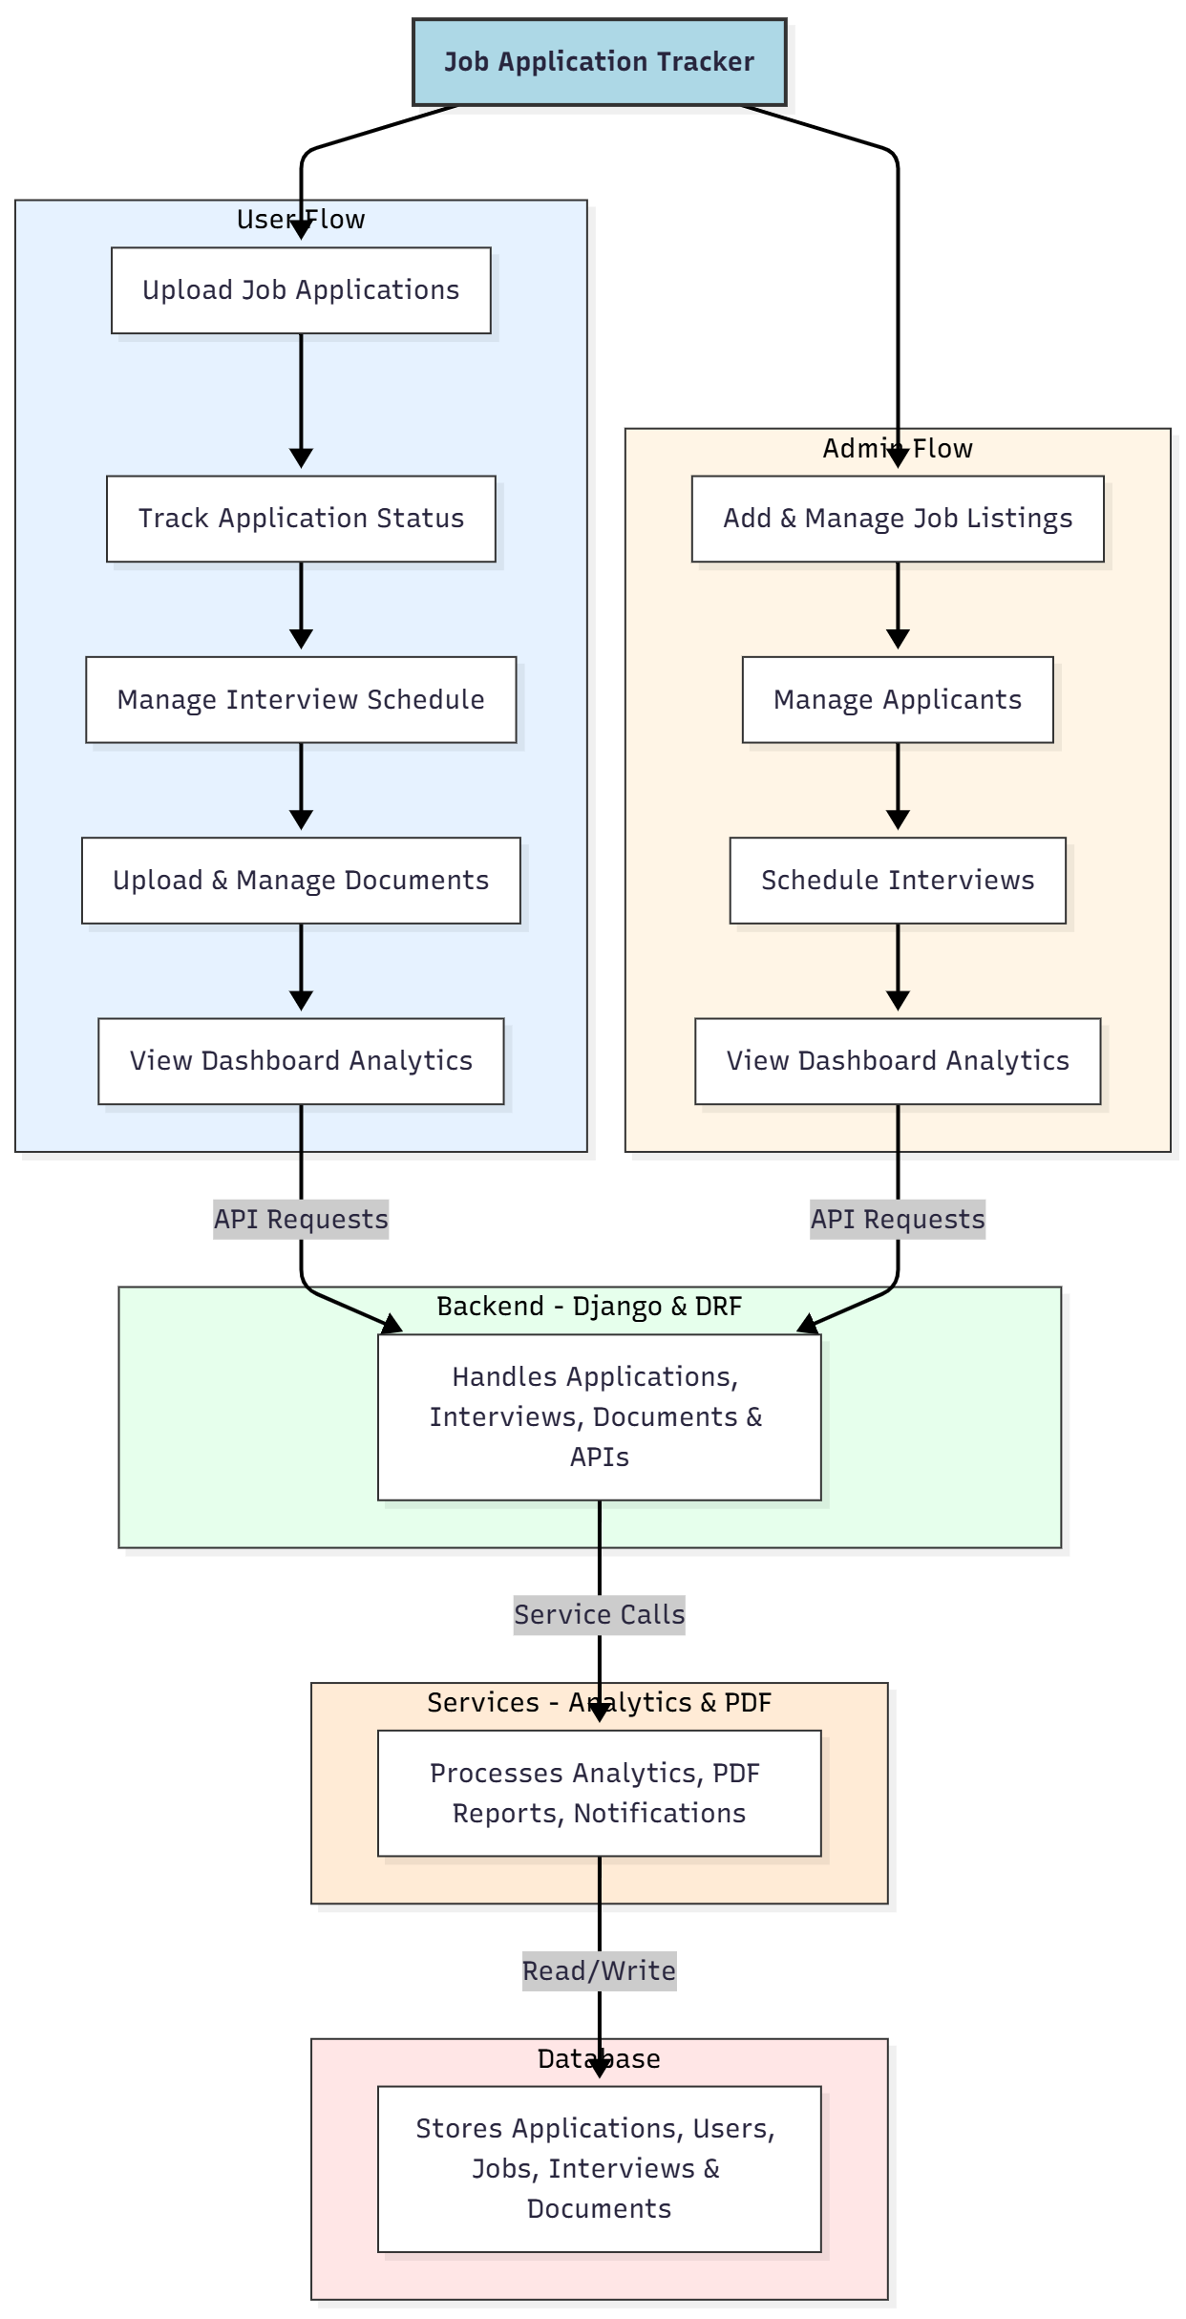

WORKING OF THE PROJECT:
Users begin by uploading job applications through the platform. Each submission is stored in the backend, with associated documents and metadata. Users can track application status, manage interview schedules, and upload supporting documents. Administrators manage job listings, track applicant submissions, schedule interviews, and generate analytics reports through dashboards. The backend handles API requests, data storage, and validation, while services process analytics, generate PDF reports, and send notifications. The database securely stores all applications, user data, job details, interviews, and documents, ensuring organized and traceable operations..

SOFTWARE REQUIREMENT:
- Backend:
  - Python 3.x
  - Django
  - Django REST Framework
  - SQLite/PostgreSQL
- Frontend:
  - Node.js and npm
  - React.js
  - Axios
- Development Tools:
  - Visual Studio Code
  - Postman (for testing APIs)
  - Git/GitHub (for version control)
- Server/Deployment (Optional):
  - Gunicorn, Nginx, or Heroku/AWS for hosting

ADVANTAGES OF THE PROJECT:

• Centralized tracking of job applications
• Easy scheduling and management of interviews
• Organized document management for applications
• Real-time status updates for users
• Dashboard analytics for insights
• PDF report generation for administrative use
• Reduces manual errors and inefficiencies
• Improves recruitment and career management workflow

APPLICATIONS OF THE PROJECT:
• Career seekers managing multiple applications
• Recruitment agencies
• Educational and career centers
• Corporate HR departments
• Job fairs and campus placement organizers
• Internship and training application tracking

REFERENCES:

- Django REST Framework Documentation — Django Software Foundation. Django Documentation. Available: https://docs.djangoproject.com/
- Django REST Framework. DRF Documentation. Available: https://www.django-rest-framework.org/
- React. React Official Documentation. Available: https://reactjs.org/docs/getting-started.html
- Redux. Redux Documentation. Available: https://redux.js.org/introduction/getting-started
- PostgreSQL Global Development Group. PostgreSQL Documentation. Available: https://www.postgresql.org/docs/
- MySQL. MySQL Reference Manual. Available: https://dev.mysql.com/doc/
- Git. Git Documentation. Available: https://git-scm.com/doc
- Node.js. Node.js Documentation. Available: https://nodejs.org/en/docs/
- Axios. Axios Documentation. Available: https://axios-http.com/docs/intro
- Socket.io Documentation – https://socket.io/docs/

